DIGITAL PERFORMANCE AUDIT
এভারকেয়ার হসপিটাল
চট্টগ্রাম
Website + Facebook + Instagram + LinkedIn + X + YouTube
অডিট সময়কাল: ১৩ মে-১৩ আগস্ট ২০২৬ | পূর্ণ KPI coverage যেখানে পাওয়া গেছে: ১৫ জুলাই-১৩ আগস্ট ২০২৬

প্রস্তুত: ১৩ আগস্ট ২০২৬ | বাংলাদেশ সময়
Decision-ready audit with verified data, limitations and a 90-day growth plan

EXECUTIVE AUDIT

১. নির্বাহী সারসংক্ষেপ
মূল রায়: Digital presence অত্যন্ত সক্রিয়, কিন্তু publishing volume audience response ও conversion measurement-কে ছাড়িয়ে গেছে। পরবর্তী growth phase-এ কম repetitive content, বেশি platform-native storytelling এবং appointment attribution জরুরি।

Signal | Verified finding | Status
Publishing load | Facebook, Instagram ও LinkedIn-এ ৩০ দিনে মোট ৯৩২ post; প্রায় ৩১.১ post/day | High risk
Audience base | Facebook 162,195; LinkedIn 4,995; Instagram 2,065; X 7 follower | FB-dependent
Best content | Clinical breakthrough, patient outcome ও local-first proof strongest attention driver | Strong
Efficiency | Facebook views +130.3%, কিন্তু reach -14.8%; Instagram posts +62.2%, engagement -37.5% | Weakening
Conversion | Click, call, message, appointment ও confirmed booking data supplied নয় | Unmeasured
Website | High-intent pathways আছে; তবে 470 বনাম 475 bed inconsistency ও stale blog sections আছে | Needs fix

EXECUTIVE AUDIT • CONTINUED

সাতটি সিদ্ধান্তযোগ্য finding
- অতিরিক্ত frequency content dilution তৈরি করছে: বেশি post হলেও প্রতি post-এর ফল proportional নয়।
- Facebook এখনও প্রধান growth engine; মোট observable social audience-এর প্রায় 95.8% এখানে।
- Clinical proof repeatable winning format, কিন্তু একই case-এর near-duplicate version audience fatigue তৈরি করতে পারে।
- Instagram visibility বাড়লেও meaningful interaction প্রায় অনুপস্থিত; platform-native creative দরকার।
- LinkedIn audience growth ইতিবাচক, কিন্তু 270 post-এর তুলনায় 427 interaction কম; employer brand ও leadership content বাড়াতে হবে।
- X profile operationally অসম্পূর্ণ: 62 post, 7 follower, blank header এবং bio-তে strong conversion path নেই।
- Website ও social থেকে appointment attribution নেই; privacy-safe analytics ছাড়া media ROI জানা যাবে না।

EVIDENCE FRAMEWORK

২. অডিটের scope, data coverage ও সীমাবদ্ধতা
এই রিপোর্টের scope পূর্ণ তিন মাস (১৩ মে-১৩ আগস্ট ২০২৬), কিন্তু সব platform-এর পূর্ণ ৯০ দিনের KPI export পাওয়া যায়নি। তাই verified quantitative data এবং public/qualitative observation আলাদা রাখা হয়েছে; কোনো missing metric অনুমান করে পূরণ করা হয়নি।
Channel | Coverage | Audit treatment
Website | Public pages reviewed; dated activity across full 3-month window | Content freshness, UX, SEO signals, trust ও conversion pathway
Facebook | 15 Jul-13 Aug full KPI + 15 Jun-14 Jul comparison + 13 May-14 Jun qualitative sample | Quantitative MoM + 3-month scope narrative
Instagram | 15 Jul-13 Aug full KPI + comparison period | 30-day verified performance; earlier month not claimed
LinkedIn | 15 Jul-13 Aug full KPI; comparison fields partly non-meaningful | Current-period performance + public profile review
X | Current profile screenshot only | Profile completeness and visible scale; no engagement totals claimed
YouTube | Public profile snapshot; no channel analytics export | Presence and content-system recommendations only
Important: Facebook/Instagram/LinkedIn engagement definitions এক নয়। তাই cross-platform engagement totals বা rates সরাসরি তুলনা করা উচিত নয়।

Audit status legend
Status | Meaning
Strong | বর্তমান execution শক্তিশালী; scale করা যায়
Watch | ফল আছে, কিন্তু efficiency বা consistency issue রয়েছে
Priority gap | তাৎক্ষণিক corrective action দরকার
Not measurable | সিদ্ধান্তের জন্য প্রয়োজনীয় data অনুপস্থিত

OMNICHANNEL OVERVIEW

৩. Channel portfolio snapshot
Platform | Followers | Posts (30d) | Engagement | Reach / views | Assessment
Facebook | 162,195 | 349 | 18,913 | 48.7K reach; 538.2K post views | Scale leader; efficiency down
Instagram | 2,065 | 313 | 65 | 26.7K reach; 42.0K views | Over-published; low interaction
LinkedIn | 4,995 | 270 | 427 | 10.6K reach; 26.9K impressions | Growth, modest response
X | 7 | 62 lifetime shown | Not supplied | Not supplied | Channel not yet built
YouTube | 4.19K public snapshot | Not supplied | Not supplied | 2.5K videos public snapshot | Large archive; analytics gap
Source note: 30-day metrics are from supplied Socialinsider exports [S1-S6]. X comes from the supplied 13 Aug screenshot [S7]. YouTube is a public snapshot [S13].
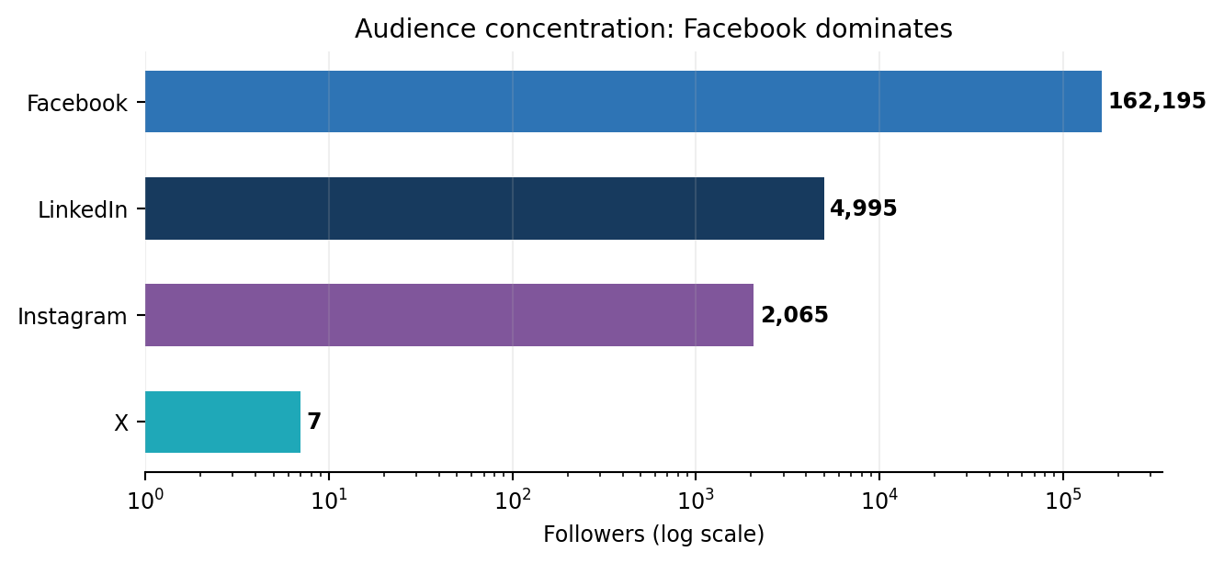
Figure 1. Observable follower base is highly concentrated on Facebook. Log scale is used so smaller channels remain visible.

Portfolio diagnosis
- Facebook protects mass reach, but the brand is vulnerable to a single-platform dependency.
- Instagram and LinkedIn are being used almost like syndication feeds; frequency is not aligned with audience size or platform behavior.
- X should not receive high-volume automated posting until profile fundamentals, conversation strategy and follower acquisition are fixed.

OWNED MEDIA AUDIT

৪. Website audit: evercarebd.com/en/chattogram
Verdict: Strong service architecture and clear high-intent actions, but content freshness is uneven, brand facts are inconsistent, and conversion performance cannot be measured from the supplied evidence.

Last-three-month activity
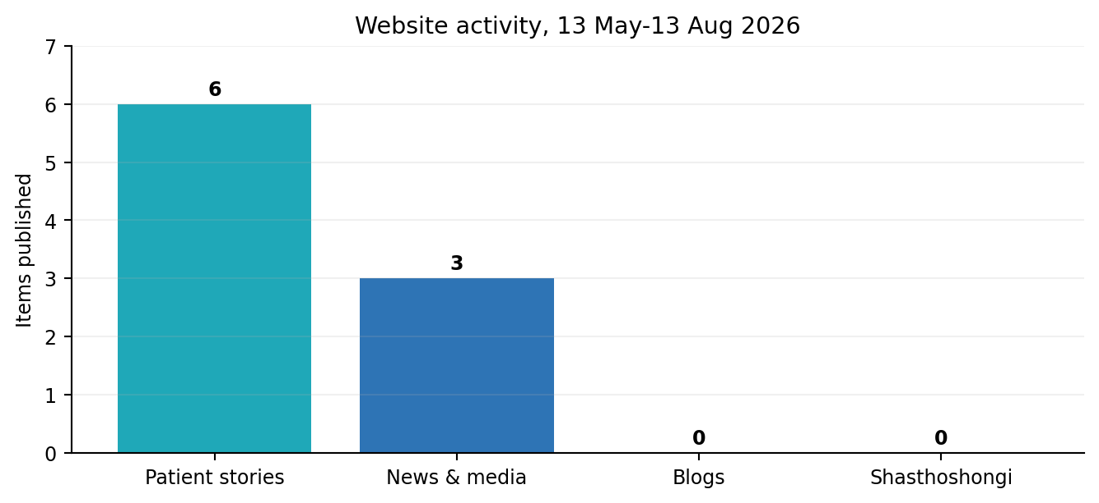
Homepage review identified 6 dated patient stories (20 May, 23 May, 3 Jun, 14 Jul, 24 Jul, 25 Jul) and 3 News & Media items (22 Jun, 12 Jul, 22 Jul) within the audit window. However, the latest visible Blog items were from March 2025 and the latest “Shasthoshongi” entries from January 2026. [S8]

Strengths
- Top-level high-intent actions are prominent: Find a Doctor, Request an Appointment, Online Report and Tele-Online.
- 29+ speciality navigation, health packages, patient stories and emergency information support the full patient journey.
- Hotline 10663 is visible; emergency page also lists ambulance 01313-779966.
- Recent patient stories and clinical news provide credible social-proof assets for search and social distribution.

Priority gaps
Issue | Evidence | Recommended action | Priority
Bed-count inconsistency | Homepage says 475-bed; About page and social profiles say 470-bed | Approve one master fact and update every channel within 7 days | P0
Stale editorial hubs | Blog latest visible items: Mar 2025; Shasthoshongi: Jan 2026 | Publish 2 search-led articles/week and refresh old high-value pages | P1
Generic image labels | Several images surface as “slider”, “partner logo”, or generic labels | Write meaningful alt text and descriptive filenames | P1
Conversion attribution | No session, CTA click, call, form-start or appointment data supplied | Configure privacy-reviewed GA4 events, call tracking and UTMs | P0
Emergency discoverability | Ambulance number is deeper on emergency page | Add labelled emergency/ambulance action to sticky mobile header | P1
Content integration | Social winners are not consistently converted into long-lived search assets | Turn clinical proof into case pages with consent and service CTA | P1

Technical/SEO note
This audit reviewed public content, information architecture and observable search/accessibility signals; it did not run authenticated GA4, Search Console, server-log or Core Web Vitals diagnostics. A true technical audit should add mobile Lighthouse tests, index coverage, structured data, crawl errors, page templates, redirect chains and form error tracking.

Website: first 30-day quick wins
- Week 1: approve the master facts sheet and correct bed count, phone labels and About copy everywhere.
- Week 2: add meaningful image alt text, review mobile emergency CTA and validate appointment forms.
- Week 3: publish two search-led health articles and convert one clinical winner into a case page.
- Week 4: report organic sessions, service-page engagement, call clicks and appointment starts by source.

PLATFORM AUDIT

৫. Facebook audit
Verdict: Facebook is the strongest channel. High output drove a major view spike, but unique reach and per-post efficiency weakened; results are concentrated in a few clinical breakthrough stories.

KPI | 15 Jun-14 Jul | 15 Jul-13 Aug | Change
Posts | 246 | 349 | +41.9%
Total engagement | 17,127 | 18,913 | +10.4%
Post views | 233,721 | 538,165 | +130.3%
Total reach | 57,166 | 48,700 | -14.8%
Reactions | 16,373 | 17,389 | +6.2%
Comments | 286 | 697 | +143.7%
Shares | 468 | 827 | +76.7%
Engagement / post | 69.6 | 54.2 | -22.2%
Reach / post | 374.4 | 223.9 | -40.2%
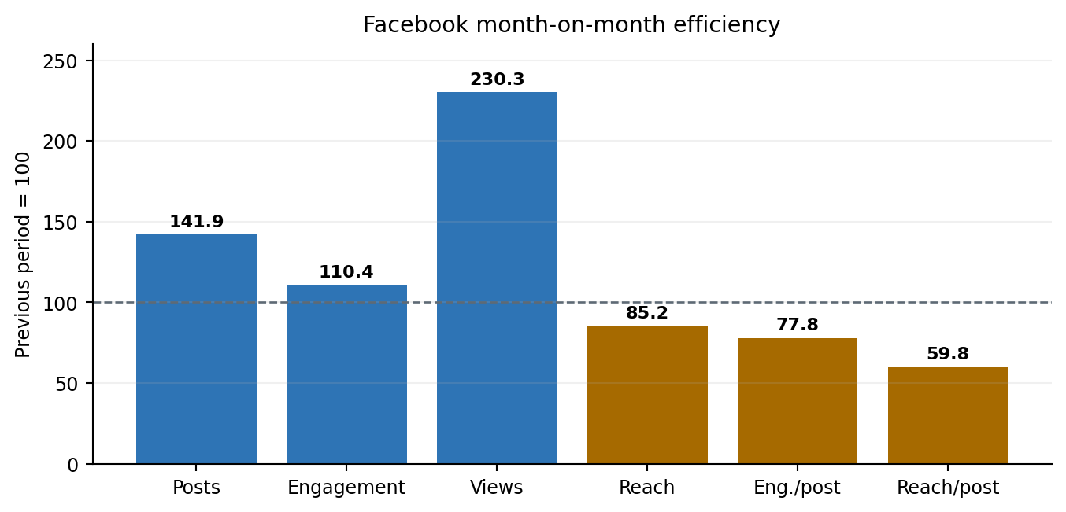
Interpretation: views grew much faster than engagement, while unique reach declined. This is consistent with repeat viewing and viral concentration rather than broad, consistent distribution. [S1-S2]

Performance concentration
Measure | Top 3 posts | Monthly total | Share
Views | 293,382 | 538,165 | 54.5%
Reactions | 7,643 | 17,389 | 44.0%
Comments | 167 | 697 | 24.0%

FACEBOOK AUDIT • CONTINUED

Top content pattern
Rank | Date / format | Story | Result
1 | 25 Jul | Reel | বাংলাদেশে প্রথম successful brainstem glioma radiotherapy case | 2.48% ER; 205.6K views; 3,728 reactions; 88 comments
2 | 26 Jul | Reel | Ventilator-supported complex brainstem cancer treatment | 1.34% ER; 81.0K views; 1,990 reactions; 66 comments
3 | 28 Jul | Photo | Dhaka-এর বাইরে first bone marrow transplant center | 1.23% ER; 6.8K views; 1,925 reactions; 13 comments

What to keep / change
Keep | Change
Clinical proof, Bangla-first storytelling, strong novelty, doctor/facility evidence | Same case-এর near-duplicate uploads; এক story-কে distinct series angles-এ ভাগ করুন
Reels as discovery format; comments/shares growth | 11.6 post/day থেকে 4-6 post/day controlled test
Hotline and service CTA | UTM, click-to-call, Messenger and confirmed booking attribution যোগ করুন
Patient stories with consent | Medical details comments-এ নেওয়া বন্ধ করে secure escalation workflow দিন

Facebook measurement checklist
Track paid/organic reach, non-follower reach, 3-second and 15-second video views, completion rate, link clicks, calls, messages, appointment starts and confirmed bookings by service line.

PLATFORM AUDIT

৬. Instagram audit
Verdict: Visibility is not converting into community response. 313 posts generated only 65 interactions; the account needs a major cadence and creative reset.

KPI (15 Jul-13 Aug) | Result | Read-out
Followers | 2,065; +16 | Audience growth +0.8%, but growth slowed
Posts | 313 (10.43/day) | +62.18% vs prior period
Total engagement | 65 | -37.5% despite more posts
Avg engagement/post | 0.21 | -61.46%
Views | 42,026 | +22%
Estimated reach | 26,712 | +23.24%
Content mix | 189 images; 124 reels | Reels drove 45 of 65 interactions
Likes / comments | 63 / 2 | Almost no conversation
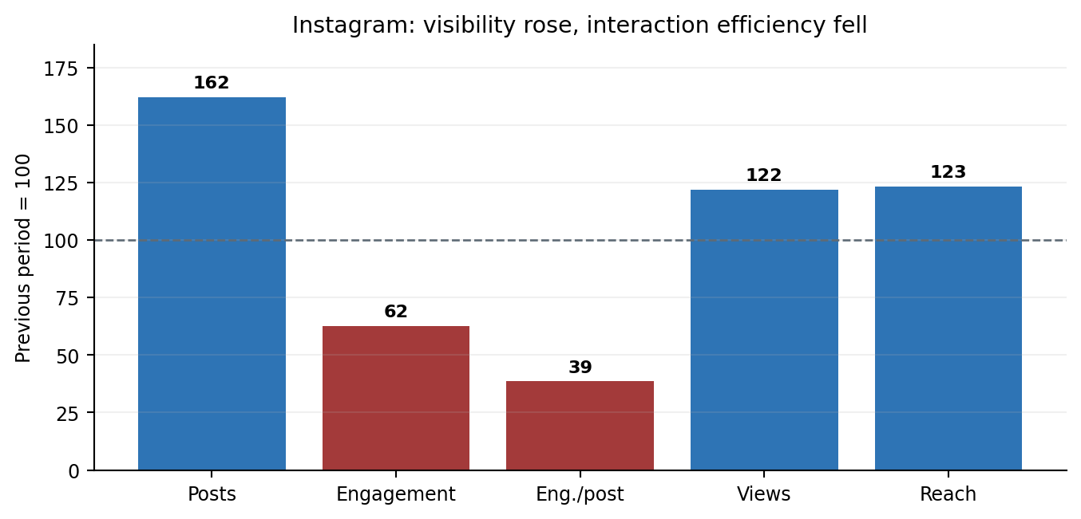
Top-engagement posts were tied at only 3 likes and 0 comments. This indicates that the page is functioning more as a high-volume distribution feed than an engaged Instagram community. [S3-S4]

Instagram reset
- Cadence: 10.4/day থেকে 2-3/day; repetitive cross-posting বন্ধ করে platform-native sequencing করুন।
- Reels: first 1.5 seconds-এ symptom/outcome hook; 20-40 second core; Bangla subtitles; one CTA.
- Carousels: “কখন ডাক্তার দেখাবেন”, “৩টি warning sign”, “test কীভাবে হয়” format ব্যবহার করুন।
- Stories: daily Q&A, polls, doctor availability, event reminders and link stickers; feed volume কমান।
- Community: every meaningful comment-এর response; medical diagnosis public reply-তে নয়।
- Profile: service link hub, click-to-call, appointment and emergency CTA স্পষ্ট করুন।
PLATFORM AUDIT

৭. LinkedIn audit
Verdict: Follower growth is positive, but publishing volume is far above professional-audience response. LinkedIn needs fewer posts and more leadership, workplace culture, research and institutional proof.

KPI (15 Jul-13 Aug) | Result | Diagnosis
Followers | 4,995; +73 (+1.48%) | Strongest proportional follower growth among measured channels
Posts | 270 (9/day) | Too high for audience size and LinkedIn behavior
Engagement | 427 (407 reactions, 9 comments, 11 shares) | Lightweight reaction-heavy response
Avg engagement/post | 1.6 | Modest
Impressions / reach | 26,877 / 10,551 | Visibility exists; deeper interaction is limited
Video | 113 videos; 17,939 views | Video is the most efficient reported format
Mix | 147 images; 113 videos; 10 documents | Document/carousel opportunity underused

Top content
Date | Theme | Result
26 Jul | Ventilator-supported complex brainstem case | 3.28% ER; 153 reactions; 4 comments
12 Aug | EHD/EHC Great Place to Work certification | 1.14% ER; 51 reactions; 3 comments
25 Jul | GO GREATER culture story | 0.72% ER; 35 reactions
PLATFORM AUDIT • CONTINUED

LinkedIn content system
- Cadence: 9/day থেকে 1-2/day; quality and employee amplificationকে priority দিন।
- Pillars: clinical innovation 30%, leadership POV 20%, employer brand 20%, partnerships/research 15%, patient journey 15%.
- Use document posts for case-learning, service pathways and clinical education; avoid promo-card repetition.
- Leadership and consultant voices থেকে original posts, not only corporate-page reposts.
- Track clicks, job applications, event registrations, partner enquiries and high-quality comments.

PLATFORM AUDIT

৮. X (Twitter) audit
Verdict: The account exists but is not yet a meaningful acquisition or reputation channel. Profile completeness and follower development should precede high-volume syndication.

Visible field | Observed value | Audit implication
Handle | @evercarectg | Consistent with Instagram and searchable
Posts | 62 | Some activity exists; 3-month post-level export not supplied
Followers / following | 7 / 1 | Negligible network and distribution
Joined | August 2024 | Low growth despite account age
Header image | Blank / grey in supplied screenshot | Major branding and trust gap
Bio | 470-bed hospital description | No hotline, website or appointment action visible
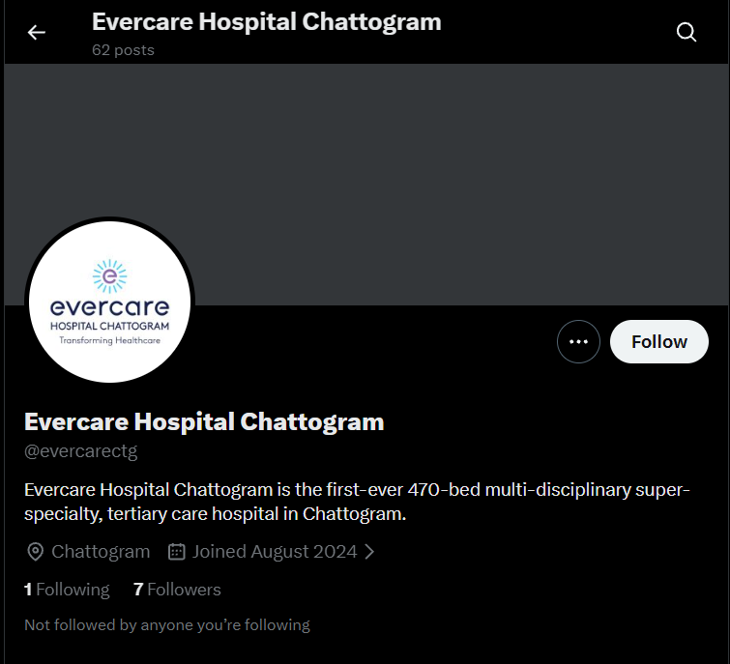
Figure 2. Supplied X profile screenshot, 13 August 2026. [S7]

PLATFORM AUDIT • CONTINUED

90-day X plan
- Add branded header, website, hotline/appointment link and Chattogram location consistency.
- Publish 2-4 useful posts/day: emergency alerts, short doctor tips, event updates and service explainers.
- Reply to relevant local health/news conversations; do not operate as a one-way auto-post feed.
- Build lists for Chattogram media, health journalists, corporate partners and community organisations.
- Target: first 50 relevant followers and a reliable response workflow; follower count alone নয়, qualified network quality measure করুন।

X 4-week build scorecard
Week | Build milestone | Measure
1 | Header, bio, website and hotline live | 100% profile completeness
2 | Local media/partner list and reply routine | 20 relevant accounts engaged
3 | Emergency, doctor-tip and event content rhythm | >=10 meaningful replies/interactions
4 | Review link clicks, follows and response quality | First 25-50 relevant followers

PLATFORM AUDIT

৯. YouTube presence audit
Verdict: The public channel has meaningful scale and a very large video archive, but no period analytics export was supplied; performance, retention and subscriber conversion cannot be validated.

Public snapshot | Observed | Action
Channel | @EvercareHospitalChattogram | Keep naming and About facts consistent with website
Subscribers | Approx. 4.19K | Track subscriber growth by source and content series
Videos | Approx. 2.5K | Audit duplication, titles, playlists and outdated offers
Recent theme examples | Clinical success, patient stories, doctor education | Organise into service-line playlists
Analytics | Not supplied | Export views, watch time, average percentage viewed, CTR and subscribers gained

Recommended YouTube system
- 3 content tiers: Shorts for discovery, 3-6 minute explainers for education, 8-20 minute expert sessions for authority.
- Every video: descriptive Bangla/English title, custom thumbnail, chapters where relevant, service link and hotline.
- Build playlists by Cancer, Cardiac, Neuro, Women & Child, Emergency, Patient Stories and Doctor Talks.
- Avoid uploading near-identical clips; select one master video and supporting Shorts with distinct hooks.
- Use privacy/consent documentation for every patient story and remove expired package claims promptly.

CONTENT SYSTEM

১০. Cross-channel content ও brand audit

Winning creative formula
Element | Winning pattern | Execution standard
Hook | Novelty + outcome + local relevance | First line / first 2 seconds-এ clear benefit or breakthrough
Proof | Doctor + facility + method | Plain-language explanation; jargon minimised
Human story | High stakes, emotionally clear | Documented consent; minimum necessary medical detail
Accessibility | Bangla-first, readable | Burned-in subtitles, contrast, meaningful alt text
CTA | One service-linked action | 10663, message, or tracked appointment page - একটিই primary CTA
Repurposing | One idea, platform-native outputs | Identical file/caption cross-post নয়; audience intent অনুযায়ী edit

Recommended monthly content allocation
Pillar | Target share | Job to be done | Best formats
Health education | 30% | Symptoms, prevention, tests and when to seek care | Short reels, carousels, explainers
Clinical proof | 25% | Outcomes, expertise, technology and multidisciplinary care | Hero reel, case page, document post
Doctor/service access | 20% | Doctor availability, pathways, emergency and booking | Reel, static card, stories
Patient/community trust | 15% | Humanise care, culture, events and patient experience | Photo story, LinkedIn, YouTube
Packages/offers | 10% | Drive action without making feed a price list | Static, landing page, remarketing

Brand consistency checklist
- Use one approved bed count across homepage, About, bios, press boilerplate and channel descriptions.
- Standardise hospital name: “Evercare Hospital Chattogram”; use @evercarectg consistently where available.
- Label all phone numbers: hotline, appointment, ambulance, switchboard - যাতে conflicting মনে না হয়।
- Maintain one evergreen About copy and update it through a controlled content-owner process.
- Use bilingual terminology consistently: Chattogram/চট্টগ্রাম, speciality names, doctor titles and emergency language.

MEASUREMENT AND GOVERNANCE

১১. Conversion, community management ও healthcare privacy

Minimum measurement framework
Funnel stage | Core KPI | Implementation
Awareness | Unique/non-follower reach, video completion, frequency | Platform analytics by paid/organic and service line
Consideration | Service-page sessions, engaged time, doctor/profile views | GA4 content groups and UTMs
Intent | Click-to-call, message, appointment start, form start | Event tracking with source/campaign parameters
Conversion | Confirmed appointment, qualified enquiry, attended appointment | CRM/appointment-system reconciliation
Service quality | Response time, unanswered rate, escalation closure | Inbox SLA dashboard and tagged cases
Learning | Median performance, top-10 contribution, creative fatigue | Weekly post-level scorecard
Privacy guardrail: Health condition, appointment reason, patient identifiers বা diagnosis-related details ad-platform pixels/UTMs-এ পাঠাবেন না। Analytics design অবশ্যই consent, legal/privacy review এবং minimum-data principle অনুসরণ করবে।

Community response SOP
- Public reply: acknowledge + safe general guidance + secure channel invitation.
- Emergency cues: immediately direct to 10663 / emergency department; social team diagnosis দেবে না।
- Sensitive details: hide/remove when appropriate and move conversation to secure, authorised channel.
- Escalation: clinical, billing, appointment and complaint categories with named owner and SLA.
- Monthly QA: unanswered questions, response accuracy, sentiment and resolution rate review.

OPERATING PLAN

১২. ৯০ দিনের action plan
Phase | Actions | Deliverables
Days 1-30  CONTROL | Fix 470/475 inconsistency; rebuild X profile; reduce cadence; tag every post by pillar/service/format; implement UTMs and response SOP; baseline medians. | Master facts sheet; channel profile checklist; tracked-link standard; weekly dashboard; cadence-test report
Days 31-60  BUILD | Launch Clinical Breakthrough, Ask the Specialist and Patient Pathway series; create service landing pages; Bangla subtitle templates; LinkedIn leadership calendar. | 12 hero stories; 8 expert reels; 4 landing pages; 4 LinkedIn documents; reusable templates
Days 61-90  SCALE | Boost proven organic winners; retarget engaged audiences with privacy review; improve SEO hubs; reconcile leads with confirmed appointments; reallocate by service. | Paid/organic scorecard; booking funnel; refreshed blog hub; quarterly allocation decision

Platform cadence test
Channel | Current | 90-day operating hypothesis | Success signal
Facebook | 11.6/day | 4-6/day | Median engagement/post and reach/post improve
Instagram | 10.4/day | 2-3/day + daily Stories | Engagement/post >=0.5 in first 30 days; comments/saves grow
LinkedIn | 9/day | 1-2/day | Avg engagement/post >=3; comments/shares rise
X | No period cadence | 2-4 useful posts/day + replies | 50 relevant followers and response workflow
YouTube | Not supplied | 3-5 Shorts + 1-2 long videos/week | Watch time, retention and subscriber conversion improve
Website | Uneven | 2 blogs/week; 2 patient stories/month; 2 news/month | Organic sessions and appointment starts grow
Targets are operating hypotheses, not guarantees. Review after the first 30-day test and adjust by service line, audience segment, paid support and clinical seasonality.

PERFORMANCE TARGETS

১৩. KPI baseline ও ৯০ দিনের target
KPI | Current baseline | 90-day target | Why it matters
Facebook engagement/post | 54.2 | 65-70 | Recover prior efficiency while reducing volume
Facebook reach/post | 223.9 | 280-300 | Reverse distribution dilution
Instagram engagement/post | 0.21 | >=0.5 at day 30; >=1.0 by day 90 | Build meaningful platform-native response
Instagram follower growth | +16/month | +30-50/month | Improve discoverability and community value
LinkedIn engagement/post | 1.6 | >=3.0 | Turn reach into professional interaction
X relevant followers | 7 | >=50 | Build a qualified local network
Tracked campaign posts | Not supplied | 100% | Attribute calls, messages and appointments
Comment response | Not supplied | >=90% within SLA | Protect trust and service quality
Website appointment funnel | Not supplied | Baseline in 30 days; +20% qualified starts by day 90 | Connect content to patient action

Weekly decision dashboard
Area | Review weekly
Content efficiency | Median engagement/post, reach/post, saves/shares, top-10 contribution
Video quality | 3-sec view, 15-sec view, completion, average watch time, non-follower reach
Conversion | Click-to-call, messages, appointment starts, confirmed bookings, cost per qualified action
Operations | Response time, unanswered questions, escalations and resolved complaints
Governance | Consent status, expired offers, factual consistency and privacy exceptions

Decision rules
- Scale a format only when median efficiency improves - not because one post went viral.
- Pause or rewrite a series when reach/post and meaningful actions fall for two consecutive weeks.
- Move budget toward service lines that generate qualified appointment actions, subject to privacy review.

DECISION

১৪. চূড়ান্ত সুপারিশ
Recommended direction: Evercare Chattogram-এর digital problem content shortage নয়; problem হলো excessive distribution, uneven channel maturity এবং unmeasured conversion. তাই “more posts” নয়—“fewer stronger stories + measurable patient pathways” হবে next-quarter operating principle.

Top 10 actions in priority order
# | Priority | Action
1 | P0 | 470/475 bed count এবং phone labels-এর master fact sheet approve করুন।
2 | P0 | All campaign posts-এ privacy-reviewed UTM, click-to-call and appointment tracking দিন।
3 | P0 | Facebook/Instagram/LinkedIn cadence controlled test শুরু করুন।
4 | P0 | Comment/message response SLA এবং medical escalation SOP চালু করুন।
5 | P1 | Clinical breakthrough content series তৈরি করুন; near-duplicate uploads বন্ধ করুন।
6 | P1 | Instagram platform-native Reels, carousels ও Stories system চালু করুন।
7 | P1 | LinkedIn leadership/employer-brand/document content বাড়ান।
8 | P1 | X profile fully brand করুন এবং qualified local network build করুন।
9 | P1 | Website blog ও Shasthoshongi editorial calendar restart করুন।
10 | P2 | YouTube archive audit, playlist redesign and retention reporting করুন।

APPENDIX

১৫. Sources, official channels ও methodology notes

Supplied files
ID | File | Use
S1 | Facebook Report(1).pdf | Socialinsider summary; 15 Jul-13 Aug 2026; comparison 15 Jun-14 Jul 2026.
S2 | Posts_evercareCTG_15_Jul_2026_13_Aug_2026_b882(1).pdf | Facebook post-level export; 102 pages.
S3 | Instagram_evercarectg_15_Jul_2026_13_Aug_2026_2c08.pdf | Instagram summary; 15 Jul-13 Aug 2026.
S4 | Posts_evercarectg_15_Jul_2026_13_Aug_2026_f239.pdf | Instagram post-level export; 102 pages.
S5 | Linkedin_Evercare_Hospital_Chattogram_15_Jul_2026_13_Aug_2026_41c7.pdf | LinkedIn summary; 15 Jul-13 Aug 2026.
S6 | Posts_Evercare_Hospital_Chattogram_15_Jul_2026_13_Aug_2026_f822.pdf | LinkedIn post-level export; 92 pages.
S7 | Screenshot 2026-08-13 203409.png | X profile screenshot supplied by user.

Official/public channel links
S8 Website: https://www.evercarebd.com/en/chattogram
S9 Facebook: https://www.facebook.com/evercareCTG/
S10 Instagram: https://www.instagram.com/evercarectg/
S11 LinkedIn: https://www.linkedin.com/showcase/evercare-hospital-chattogram/
S12 X: https://x.com/evercarectg
S13 YouTube: https://www.youtube.com/@EvercareHospitalChattogram

Top-post links used in the supplied exports
Facebook top reel 1: Open post
Facebook top reel 2: Open post
Facebook top photo: Open post
Instagram top reel 1: Open post
Instagram top reel 2: Open post
LinkedIn top post 1: Open post

APPENDIX • LIMITATIONS

Limitations
- Meta Business Suite, GA4, Search Console, YouTube Studio, X Analytics, CRM and appointment-system access was not supplied.
- Instagram and LinkedIn do not have full May-June KPI exports in the supplied files; report does not invent those totals.
- Public follower counts may change after the 13 August 2026 snapshot.
- Paid/organic split, spend, frequency, clicks, message actions, call outcomes and confirmed bookings are not available.
- Website technical performance requires a separate authenticated and device-level test suite.
Prepared for decision-making. All figures are rounded for presentation; source-file precision is retained where available.

