Evercare CTG SEO keypoints:
Bounce rate:
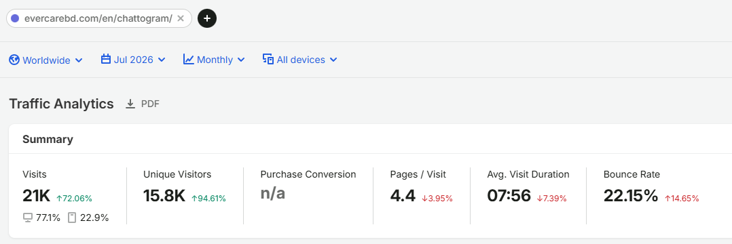
Organic traffic only 3k while Evercare dhaka gets 18k+ traffic daily
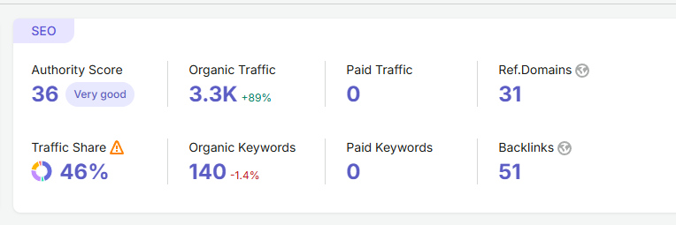
Overall traffic increase, Branded traffic is very poor
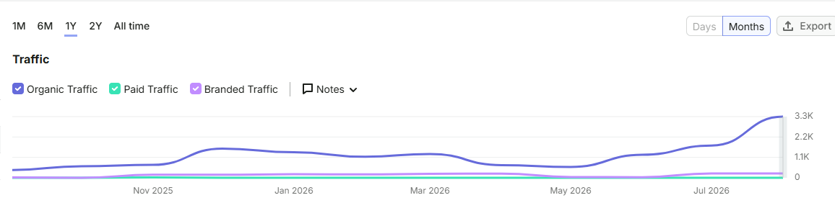
Lots of keyword left for ranks
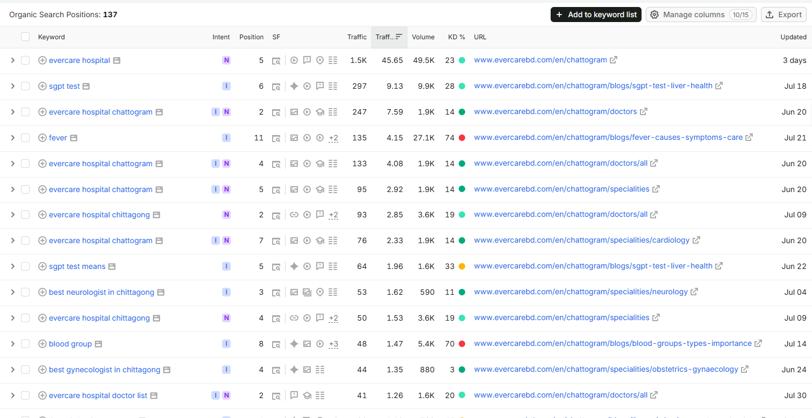
Keywords that ranks on Ai but have a lot of scope to improve
